**EXPLORE- Problem Analysis**

The requirements of this task as stated by the task sheet is to design, develop, and evaluate the process of creating an ‘interactive learning object’. The learning object has to be built with the intended audience in mind as listed in the task sheet. As stated by The University of Windsor, an interactive learning object is a tool comprised of different interactive elements such as videos and activities that assist and engage students in their learning. An interpretation of the interactive learning object model are browser-based learning games.

While browser games are generally single-player or multiplayer games played through a web browser on a device (Desktop or Mobile) for entertainment purposes. An article by Science Direct states that browser-based learning games can very positively affect students learning and can assist students in deepening their knowledge of certain subject areas. Web-based learning games are built off standard web development tools such as HTML (and CSS), and PHP for server-side programming. This project will utilise the standard web technologies, HTML, CSS, and PHP to create a single-player browser-based learning game.

**EXPLORE- Rationale**

This project will be used to create a practical browser-based interactive learning object that will serve as a functional product to assist students in their education. With browser games quickly growing and being accepted as practical educational tools, the skills learnt and applied for this project have transferability to real-life applications.

**EXPLORE- Specifications/ Objectives**

There will be multiple individual games, each will be based specifically around a subject that requires further teaching, all hosted on one primary platform (Website).

The main platform will be called ‘The Learning Hub’ and will have a simple and easily expandable UI. Each ‘Game’ will have two sections, a ‘Learning’ and a ‘Quiz’ section. The learning section will provide students with the appropriate knowledge surrounding the topic. The quiz section will test the students on their interpretation and memory abilities through a variety of simple and complex questions on the topic.

**EXPLORE- Specifications/ Audience**

The audience for this game is children aged 10 to 13, grades 5-7. In Queensland state schools, students in grade 6 are taught the fundamentals of all maths, this includes the concept of using fractions & decimals, converting between different units, percentages (with money), interest, angles, and most importantly being capable in 4 main areas, addition, subtraction, multiplication, and division without a calculator. On the English department side, students are required to be able to use coherent text structures, understand the effects & how to use language features, understand language features & patterns, and be able to use correct and consistent grammar for better cohesion in texts. Considering that grades 5 & 6 are still in primary school, the platform design will be aimed more towards the younger children while maintaining a professional feel for the slightly older students. This may entail the use of larger fonts, bright/contrasting colours, age-standard wording, and ‘less formal’ fonts.

**EXPLORE- Usability Principles**

Usability principles will be considered throughout this project include:

1. Accessibility must be considered during the development and evaluation of the prototype and final platform. To accommodate for the target audience, specific mainline design choices have been made, these include increasing the overall text size, and considering learnability.
2. Effectiveness will be judged when children are encouraged to retake quizzes to improve on their previous results, as well as by providing educational resources that cover the appropriate topics they are being assessed on.
3. The safety of the website/ platform is strictly upheld with regular backups produced by Digital Solutions Online as well as by the developer locally.
4. Utility is achieved by providing useful learning resources and simple user-end quizzes that operate effectively and effectively in the background.
5. Learnability is assumed that users already have general ‘web surfing’ abilities such as navigating through a web platform, entering data into a text form, and using radio buttons to select data choices.

**EXPLORE- Mind Map**

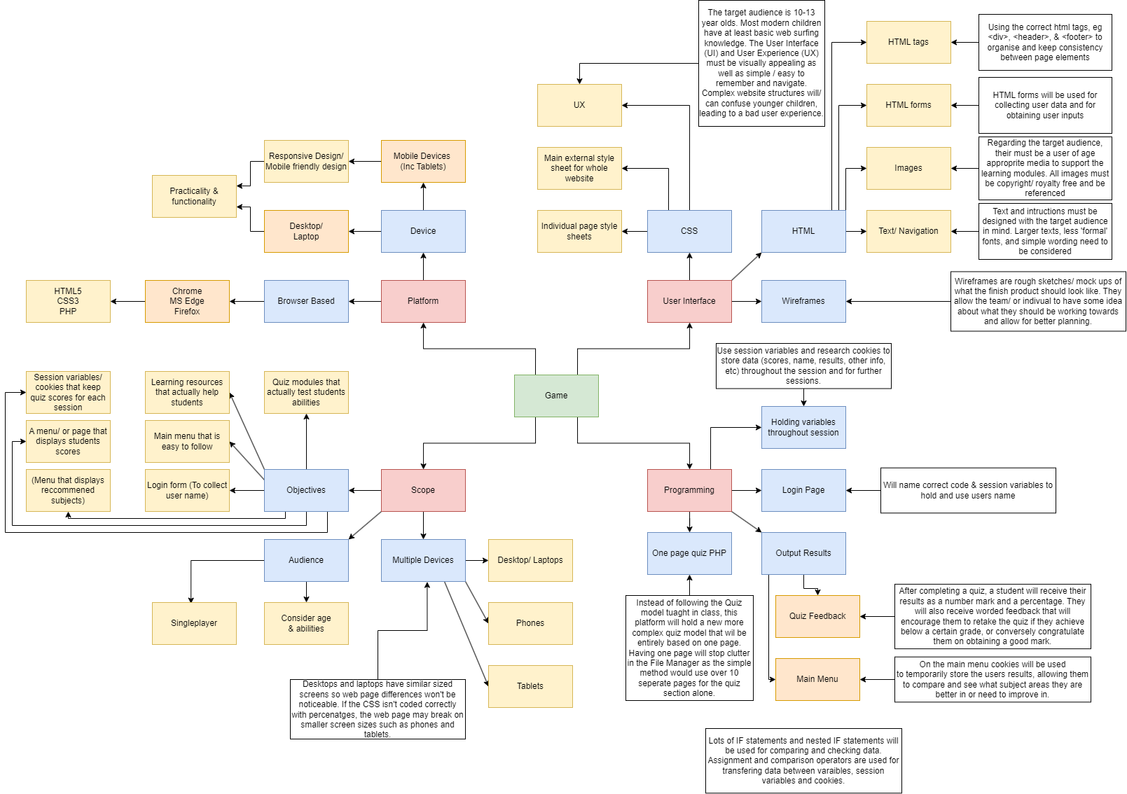

**EXPLORE- Criteria/ Prescribed**

By the due date, 8:30am 22nd May 2023:

1. A functioning prototype of ‘The Learning Hub’ platform will be coded in Digital Solutions Online.
2. Users will be able to enter their name so they can be addressed by it for a more ‘personal feel’.
3. Users will have access to at least 1 module:

* A module including 1 ‘learning resource section’ and 1 ‘Quiz section’.

1. Develop a new PHP Quiz model that is based entirely on 1 page, and that allows for more ‘add-ons’ or extra features in the future.
2. Users will receive encouraging feedback depending on their score achieved on each quiz.
3. User marks/ results will be displayed on the main menu/ homepage for ease of access.

**EXPLORE- Criteria/ Self-determined**

1. By slightly before the due date, at 10:00pm 21st May 2023:
2. (All 6 of the above)
3. Have completed building an entirely new PHP quiz program that works entirely on 1 page.

* This allows for easy copy/ pasting for the next modules on ’The Learning Hub’ Platform.

1. Personally understand and be familiarised with PHP, HTML, & CSS coding rules/ systems.
2. Have commented, indented, and appropriately used whitespace on all pages, specifically pages with complex PHP systems.
3. Have the basic UI (User Interface) built with room to improve it later.
4. Have the UX (User Experience) design understood and built to be improved later.
5. Be designed and built with the target audience in mind.
6. Only used variables, cookies and other coding systems where needed in the most efficient manner possible.

**DEVELOP- Wireframe**

A wireframe is a basic/ plain schematic blueprint of what the physical website will look like. They are used to assist in deciding what looks/ feels the best when it comes to UI and UX. Simple wireframes contain rough positioning of all the elements that will be on each page. Even simple wireframes are useful tools that assist when applying cascading style sheets (CSS) to a webpage to improve the aesthetic view of the webpage or platform which helps improve user experience.

(Show below is the login and home page.)

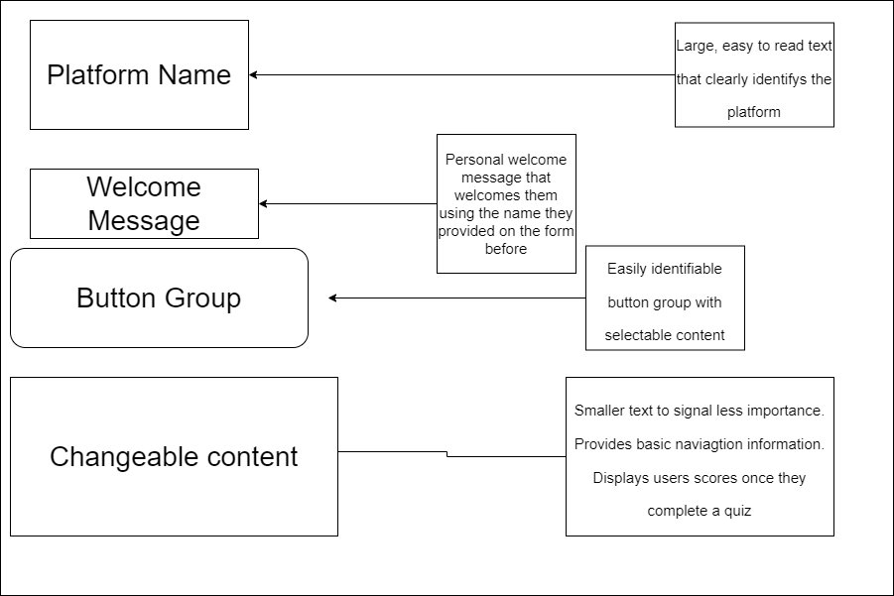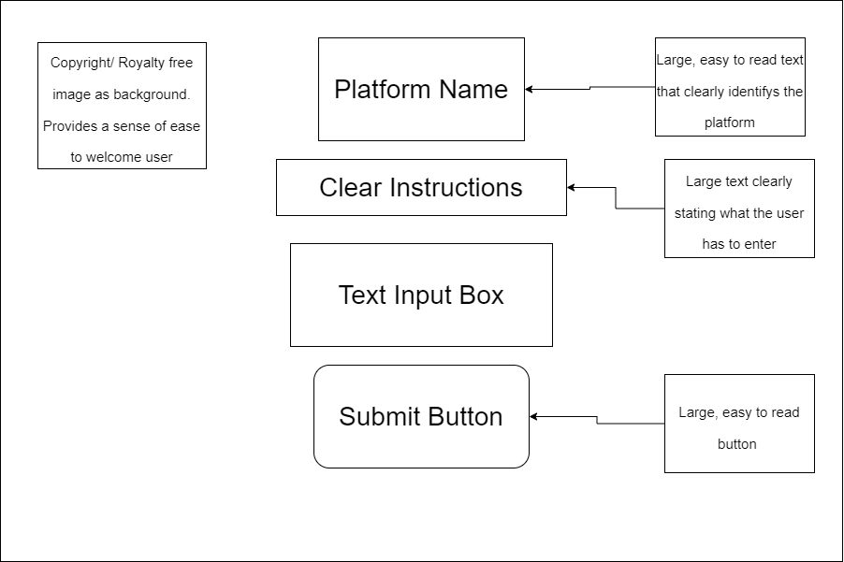

**DEVELOP- Algorithm**

(There are multiple pages each with complex code, chosen below is the quiz code.)

There are 11 ‘ans’ variables declared with blank values.

These variables are declared on a separate page for the simplicity of stopping them from getting reset every time the quiz script is run

**\*Set on a previous page**

SET SESSION VAR question to 1

SET SESSION VAR ans1 to “”

“”

SET SESSION VAR ans11 to “”

IF SESSION VAR SUBJECTscore > 1

This cookie is run when the user completes the quiz (Assuming they get at least 1 question correct). The cookie expiry time is actually set for 5 minutes for testing purposes.

SET COOKIE “SUBJECTscore” to value “SUBJECTscore” with an expiry of 86400 seconds

ENDIF

**\*Quiz Page**

IF SESSION VAR question equals 1

ECHO (1st Quiz Form)

The Quiz code is fundamentally the same from the 2nd IF statement onwards. Each consists of echoing/ printing the form for the current question while increasing the question variable which allows the user to move on to the next question. It most importantly assigns the POST value of the previous form into its corresponding session variable.

SET SESSION VAR question to 2

ENDIF

IF SESSION VAR question equals 2

ECHO (2nd Quiz Form)

SET SESSION VAR question to 3

SESSION VAR ans1 = POST 1

ENDIF

IF SESSION VAR question equals 3

ECHO (3rd Quiz Form)

SET SESSION VAR question to 4

Despite the quiz actually only being 10 questions long, the variable ticks over to 11 to process the POST information from question 10. It also serves as a convenient spot to place all of the marking code, and consequently the score page.

SESSION VAR ans2 = POST 2

ENDIF

IF SESSION VAR question equals 11

SESSION VAR ans10 = POST 11

IF SESSION VAR ans1 equals A

SESSION VAR score +1

ENDIF

IF SESSION VAR ans2 equals b

The question 11 IF statement also allows for scores to be moved from the score session variable into their own personal ‘SUBJECTscore’ variable. This is important as the score variable is universal, being used for all quiz pages. In turn meaning the current scores would be lost when the user starts a new quiz.

SESSION VAR score +1

ENDIF

SESSION VAR SUBJECTpercent equals SESSION VAR Score divided by 10, multiped by 100

SESSION VAR SUBJECTscore equals SESSION VAR Score

Print (Ending Screen)

IF SESSION VAR SUBJECTscore equal to or higher than 9

ECHO (Very Positive message) & Main menu button

ENDIF

Too add complexity to the code, the SUBJECTscore was broken apart, and sperate messages were produced depending on the user’s score. When scoring low, the user is recommended to take the quiz again, conversely, if they are sufficiently competent, they are only given a Main menu button

IF SESSION VAR SUBJECTscore between 6 & 8

ECHO (Positive message) & Main menu button * Retry button

ENDIF

IF SESSION VAR SUBJECTscore equals Less than 6

ECHO (Encouraging message) & Main menu button * Retry button

ENDIF

ENDIF

**GENERATE- Code**

**login.php (Must be run 1st)**

<?php

session_start();

?>

<html lang="en-AU">

<head>

<title>Login | TLH</title>

<meta charset="UTF-8">

<meta name="viewport" content="width=device-width, initial-scale=1">

<link rel="stylesheet" href="stylesheet.css">

<style>

body {

background-image: url('https://wallpapercave.com/wp/wp9422673.jpg');

background-repeat: no-repeat;

background-attachment: fixed;

background-size: cover;

}

</style>

</head>

<body>

<header>

<h1 class="style2">The Learning Hub</h1>

</header>

<form name="login" method="post" action="home.php" class="center" id="style2"> <!--Main Form-->

<div style="size">

<h2 class="style2" for="login">Please enter your name</h2>

<input type="text" id="login" name="name" required="true" align="center"><br><br>

<input type="submit" value="Submit" class="btn">

</form>

</body>

</html>

**Home.php**

<?php

session_start();

// The IF Statements below are for testing purposes only!

/*

if (isset($_COOKIE["GEOscore"])) {

echo ($_COOKIE["GEOscore"]);

} else {

echo "¯\_(ツ)_/¯ No cookie! :((";

}

*/

if (isset($_POST['name'])) {

$_SESSION['sname'] = $_POST['name'];

// echo 'Session is set';

} else {

//echo 'Session broken';

}

//This is here due to an error on the the Quiz page where the main menu button doesn't does go from the cookie subbmitter and the home page doesn't change!

if ($_SESSION["GEOscore"] > 1){

setcookie("GEOscore", $_SESSION["GEOscore"], time() + 300); //86400 is 1 day in Seconds // 3600 is 1 hour in Seconds //300 for testing

}

?>

<!DOCTYPE html>

<html lang="en-AU">

<head>

<title>The Learning Hub</title>

<meta charset="UTF-8">

<meta name="viewport" content="width=device-width, initial-scale=1">

<link rel="stylesheet" href="stylesheet.css">

</head>

<body>

<header>

<div class="style1">

<h1 class="style1">The Learning Hub</h1>

<h2 class="style1">Welcome, <?php echo $_SESSION['sname'];?>! </h2>

</div>

<nav>

<div class="btn-group">

<a href="page1.php"><button class="button">GEOGRAPHY</button></a>

<a href="page2.php"><button class="button">MATH</button></a>

<a href=""><button class="button">Not Yet</button></a>

<a href=""><button class="button"> Not Yet</button></a><br><br><br>

</div>

</nav>

</header>

<br><br><br><br>

<?php

if (isset($_COOKIE["GEOscore"])) { //Add other cookies here

if (isset($_COOKIE["GEOscore"])) { //Writ score for specific cookie

echo '<p>WARNING! Cookies (Scores) currently only last 5 minutes due to testing purposes';

echo '<p>GEOGRAPHY: '. $_COOKIE["GEOscore"]/10*100 . '% </p>';

}

} else {

echo ("

<p>Welcome to The Learning Hub! <br> Select one of the modules above to begin!</p>

<br>

<p>Inside each module will be a learning resource called 'LEARN!' <br> Once you finish the learning resource you can check your knowledge with the 'QUIZ!'</p> ");

}

?>

</body>

</html>

**Page1.php (Geography Module)**

<?php

session_start();

//These variables must be delcared on this page to stop it messing it up on the Quiz page!

$_SESSION["question"] = 1;

$_SESSION["ans1"] = "";

$_SESSION["ans2"] = "";

$_SESSION["ans3"] = "";

$_SESSION["ans4"] = "";

$_SESSION["ans5"] = "";

$_SESSION["ans6"] = "";

$_SESSION["ans7"] = "";

$_SESSION["ans8"] = "";

$_SESSION["ans9"] = "";

$_SESSION["ans10"] = "";

$_SESSION["ans11"] = "";

//Cookie (Error will be fixed soon :) )

if ($_SESSION["GEOscore"] > 1){

setcookie("GEOscore", $_SESSION["GEOscore"], time() + 300); //86400 is 1 day in Seconds // 3600 is 1 hour in Seconds //300 for testing

}

?>

<!DOCTYPE html>

<html lang="en-AU">

<head>

<title>Geography | The Learning Hub</title>

<meta charset="UTF-8">

<meta name="viewport" content="width=device-width, initial-scale=1">

<link rel="stylesheet" href="stylesheet.css">

<style>

.btn-group2 .button:hover {

background-color: #008fb3;

}

a {

margin: auto;

text-decoration: none;

}

.btn-group2 .button {

margin: auto;

width: 50%;

padding: 10px;

background-color: #80e5ff; /* Blue */

color: black;

font-size: 100%;

font-weight: bold;

width: 380px;

height: 50px;

padding: 20px 40px;

text-align: center;

font-size: 20px;

cursor: pointer;

float: center;

font-family: "Arial";

margin: auto;

display: flex;

justify-content: center;

align-items: center;

border: none;

}

</style>

</head>

<body>

<!-- Header -->

<header>

<div class="style1">

<h1 class="style1">The Learning Hub</h1>

<h2 class="style1">Learn the continents of the world! </h2>

<nav>

<div class="btn-group">

<a href="home.php" ><button class="button">Return</button></a>

</div>

</nav>

</div>

</header>

<br><br><br><br>

<!-- Begin button -->

<div class="btn-group2">

<a href="page1_learn.php"><button class="button" id="btn-group2">LEARN!</button></a>

<a href="page1_quiz.php"><button class="button">QUIZ!</button></a>

</div>

</body>

</html>

**Page1_learn.php (Geography Leaning section)**

<?php

session_start();

?>

<!DOCTYPE html>

<html lang="en-AU">

<head>

<title>Learn the continents! | The Learning Hub</title>

<meta charset="UTF-8">

<meta name="viewport" content="width=device-width, initial-scale=1">

<link rel="stylesheet" href="learn_style.css">

</head>

<body>

<header>

<br>

</header>

<!-- Learning Resource-->

<h1>Learn the continents!</h1>

<div class="d2"> </div>

<h2>What are continents??</h2>

<div class="d2"> </div>

<img src="images1/map3.jpg" alt="Map of the world">

<div class="d2"> </div>

<h3>Continents are large land masses that are spread across the planet.</h3>

<h3>All of the land across the Earth is broken into 7 continents.</h3>

<div class="d2"> </div>

<img src="images1/map1.png" alt="Map of the world">

<div class="d2"> </div>

<h3>Each continent has heaps of countries inside of it!</h3>

<div class="d1"> </div>

<h3 class="red">FUN FACT! There is only 7 continents, but there is 195 countries in the world!</h3>

<div class="d1"> </div>

<h3>Most of the continents start with the letter 'A' or have a word that starts with the letter 'A'</h3>

<div class="d1"> </div>

<h3 class="red">Do you know any of the continents already? HINT: Our country name is also a continent name!</h3>

<div class="d2"> </div>

<img src="images1/map2a.png" alt="Map of the world">

<div class="d2"> </div>

<h3>All continents except antarctica have people living there</h3>

<div class="d2"> </div>

<h3>To remember the 7 continents, remember 6 'A's and 1 'E'</h3>

<h3>It is easier to remember North & South Amercia with an 'A' as they both have America in the name!</h3>

<div class="d2"> </div>

<h3 class="red">FUN FACT! Asia is the biggest continent and has 4 BILLION people living there!</h3>

<div class="d2"> </div>

<h3>The odd continent with an 'E' is Europe</h3>

<div class="d2"> </div>

<h3></h3>

<form name='Return Main Menu' method='post' action='page1.php' id='btn' class="btn">

<input align='center' name='Return Main Menu' type='Submit' value='Return Main Menu' id='btn' class="button">

</form> "

<h2></h2>

<h3></h3>

</body>

</html>

**Page1_quiz.php**

<?php

session_start();

$_SESSION["Score"] = 0; // Sets Score to 0

//The code below if for testing purposes only!

//echo ($_SESSION["question"]); // Prints Q#

?>

<!DOCTYPE html>

<html>

<head>

<title>Continents Quiz!</title>

<link rel="stylesheet" href="quiz_style.css">

</head>

<body>

<h1>Continents Quiz!</h1>

<br><br>

<?php

if ($_SESSION["question"] == 11) {

$_SESSION["ans10"] = $_POST["quiz10"]; //Posts Data

//Checks each answer

if ($_SESSION["ans1"] == "B") {

$_SESSION["Score"]++;

}

if ($_SESSION["ans2"] == "C") {

$_SESSION["Score"]++;

}

if ($_SESSION["ans3"] == "D") {

$_SESSION["Score"]++;

}

if ($_SESSION["ans4"] == "A") {

$_SESSION["Score"]++;

}

if ($_SESSION["ans5"] == "A") {

$_SESSION["Score"]++;

}

if ($_SESSION["ans6"] == "D") {

$_SESSION["Score"]++;

}

if ($_SESSION["ans7"] == "B") {

$_SESSION["Score"]++;

}

if ($_SESSION["ans8"] == "C") {

$_SESSION["Score"]++;

}

if ($_SESSION["ans9"] == "A") {

$_SESSION["Score"]++;

}

if ($_SESSION["ans10"] == "B") {

$_SESSION["Score"]++;

}

//Creates session Variable that hold GEO Score

$_SESSION['GEOpercent'] = $_SESSION['Score']/10*100;

$_SESSION['GEOscore'] = $_SESSION['Score'];

// Screen items (Score)

printf ("<h1>Score</h1>");

echo '<h2>You scored '. $_SESSION['Score'] . ' out of a possible 10 ('. $_SESSION['GEOpercent'] . '%)</h2>';

if ($_SESSION['GEOscore'] >= 9 ) {

echo '<h2> Great job!</h2>';

//Main Menu

printf("

<br><br>

<!--Button asking if the user wants to return main menu.-->

<form name='Return Main Menu' method='post' action='home.php' id='style1'>

<input align='center' name='Return Main Menu' type='Submit' value='Return Main Menu' id='btn'>

</form> ");

} elseif ($_SESSION['GEOscore'] >= 6 && $_SESSION['GEOscore'] <= 8) {

echo '<h2>Good job! Remember there is always room for improvment!<h2>';

//Retry

printf("

<!--Button asking if the user wants to retry the quiz.-->

<form name='RestartQuiz' method='post' action='page1.php' id='style1'>

<input align='center' name='RestartQuiz' type='Submit' value='Try Again?' id='btn'>

</form>");

//Main Menu

printf("

<br>

<!--Button asking if the user wants to return main menu.-->

<form name='Return Main Menu' method='post' action='home.php' id='style1'>

<input align='center' name='Return Main Menu' type='Submit' value='Return Main Menu' id='btn'>

</form> ");

} else {

echo '<h2>(╯°□°)╯You might want to try again! ノ( º _ ºノ)</h2>';

//Retry

printf("

<!--Button asking if the user wants to retry the quiz.-->

<form name='RestartQuiz' method='post' action='page1.php' id='style1'>

<input align='center' name='RestartQuiz' type='Submit' value='Try Again?' id='btn'>

</form>");

//Main Menu

printf("

<br><br>

<!--Button asking if the user wants to return main menu.-->

<form name='Return Main Menu' method='post' action='home.php' id='style1'>

<input align='center' name='Return Main Menu' type='Submit' value='Return Main Menu' id='btn'>

</form> ");

}

}

?>

<!--Form ---------------------------------------------------------------------------------------------------------------------------------->

<?php

// Question 1

if ($_SESSION["question"] == 1) {

echo('

<form action="page1_quiz.php" method="post" id="style1">

<h3>Question 1: How many continents are there?</h3>

<input type="radio" id="A" name="quiz1" value="A">

<label for="A"> A) 6 </label><br>

<input type="radio" id="B" name="quiz1" value="B">

<label for="B"> B) 7 </label><br>

<input type="radio" id="C" name="quiz1" value="C">

<label for="C"> C) 8 </label><br>

<input type="radio" id="D" name="quiz1" value="D">

<label for="D"> D) 9 </label>

<br><br>

<input type="submit" value="Submit" class="submitbtn" id="btn">

</form>

');

$_SESSION["question"] = 2;

// Question 2

} elseif ($_SESSION["question"] == 2) {

echo('

<form action="page1_quiz.php" method="post" id="style1">

<h3>Question 2: What continent starts with an "E"?</h3>

<input type="radio" id="A" name="quiz2" value="A">

<label for="A"> A) Eurip </label><br>

<input type="radio" id="B" name="quiz2" value="B">

<label for="B"> B) Entarctica </label><br>

<input type="radio" id="C" name="quiz2" value="C">

<label for="C"> C) Europe </label><br>

<input type="radio" id="D" name="quiz2" value="D">

<label for="D"> D) Esia </label>

<br><br>

<input type="submit" value="Submit" class="submitbtn" id="btn">

</form>

');

$_SESSION["question"] = 3;

$_SESSION["ans1"] = $_POST["quiz1"];

// Question 3

} elseif ($_SESSION["question"] == 3) {

echo('

<form action="page1_quiz.php" method="post" id="style1">

<h3>Question 3: What continents have North & South at the begnning?</h3>

<input type="radio" id="A" name="quiz3" value="A">

<label for="A"> A) Australia </label><br>

<input type="radio" id="B" name="quiz3" value="B">

<label for="B"> B) Asia </label><br>

<input type="radio" id="C" name="quiz3" value="C">

<label for="C"> C) Europe </label><br>

<input type="radio" id="D" name="quiz3" value="D">

<label for="D"> D) America </label>

<br><br>

<input type="submit" value="Submit" class="submitbtn" id="btn">

</form>

');

$_SESSION["question"] = 4;

$_SESSION["ans2"] = $_POST["quiz2"];

// Question 4

} elseif ($_SESSION["question"] == 4) {

echo('

<form action="page1_quiz.php" method="post" id="style1">

<h3>Question 4: What is a continent?</h3>

<input type="radio" id="A" name="quiz4" value="A">

<label for="A"> A) A large land mass </label><br>

<input type="radio" id="B" name="quiz4" value="B">

<label for="B"> B) A big country </label><br>

<input type="radio" id="C" name="quiz4" value="C">

<label for="C"> C) An ocean </label><br>

<input type="radio" id="D" name="quiz4" value="D">

<label for="D"> D) A road </label>

<br><br>

<input type="submit" value="Submit" class="submitbtn" id="btn">

</form>

');

$_SESSION["question"] = 5;

$_SESSION["ans3"] = $_POST["quiz3"];

// Question 5

} elseif ($_SESSION["question"] == 5) {

echo('

<form action="page1_quiz.php" method="post" id="style1">

<h3>Question 5: What continent do we live on?</h3>

<input type="radio" id="A" name="quiz5" value="A">

<label for="A"> A) Australia </label><br>

<input type="radio" id="B" name="quiz5" value="B">

<label for="B"> B) North America </label><br>

<input type="radio" id="C" name="quiz5" value="C">

<label for="C"> C) Antarctica </label><br>

<input type="radio" id="D" name="quiz5" value="D">

<label for="D"> D) Europe </label>

<br><br>

<input type="submit" value="Submit" class="submitbtn" id="btn">

</form>

');

$_SESSION["question"] = 6;

$_SESSION["ans4"] = $_POST["quiz4"];

//Question 6

} elseif ($_SESSION["question"] == 6) {

echo('

<form action="page1_quiz.php" method="post" id="style1">

<h3>Question 6: What continent has the most people?</h3>

<input type="radio" id="A" name="quiz6" value="A">

<label for="A"> A) North America </label><br>

<input type="radio" id="B" name="quiz6" value="B">

<label for="B"> B) South America </label><br>

<input type="radio" id="C" name="quiz6" value="C">

<label for="C"> C) Antarctica </label><br>

<input type="radio" id="D" name="quiz6" value="D">

<label for="D"> D) Asia </label>

<br><br>

<input type="submit" value="Submit" class="submitbtn" id="btn">

</form>

');

$_SESSION["question"] = 7;

$_SESSION["ans5"] = $_POST["quiz5"];

//Question 7

} elseif ($_SESSION["question"] == 7) {

echo('

<form action="page1_quiz.php" method="post" id="style1">

<h3>Question 7: What continent has no one living on it?</h3>

<input type="radio" id="A" name="quiz7" value="A">

<label for="A"> A) South America </label><br>

<input type="radio" id="B" name="quiz7" value="B">

<label for="B"> B) Antarctica </label><br>

<input type="radio" id="C" name="quiz7" value="C">

<label for="C"> C) Europe </label><br>

<input type="radio" id="D" name="quiz7" value="D">

<label for="D"> D) Egypt </label>

<br><br>

<input type="submit" value="Submit" class="submitbtn" id="btn">

</form>

');

$_SESSION["question"] = 8;

$_SESSION["ans6"] = $_POST["quiz6"];

//Question 8

} elseif ($_SESSION["question"] == 8) {

echo('

<form action="page1_quiz.php" method="post" id="style1">

<h3>Question 8: What continents are bigger than Australia?</h3>

<input type="radio" id="A" name="quiz8" value="A">

<label for="A"> A) China </label><br>

<input type="radio" id="B" name="quiz8" value="B">

<label for="B"> B) South America </label><br>

<input type="radio" id="C" name="quiz8" value="C">

<label for="C"> C) All of them </label><br>

<input type="radio" id="D" name="quiz8" value="D">

<label for="D"> D) Antarctica </label>

<br><br>

<input type="submit" value="Submit" class="submitbtn" id="btn">

</form>

');

$_SESSION["question"] = 9;

$_SESSION["ans7"] = $_POST["quiz7"];

//Question 9

} elseif ($_SESSION["question"] == 9) {

echo('

<form action="page1_quiz.php" method="post" id="style1">

<h3>Question 9: What continent has the country Egypt?</h3>

<input type="radio" id="A" name="quiz9" value="A">

<label for="A"> A) Africa </label><br>

<input type="radio" id="B" name="quiz9" value="B">

<label for="B"> B) Europe </label><br>

<input type="radio" id="C" name="quiz9" value="C">

<label for="C"> C) Antarctica </label><br>

<input type="radio" id="D" name="quiz9" value="D">

<label for="D"> D) America </label>

<br><br>

<input type="submit" value="Submit" class="submitbtn" id="btn">

</form>

');

$_SESSION["question"] = 10;

$_SESSION["ans8"] = $_POST["quiz8"];

//Question 10

} elseif ($_SESSION["question"] == 10) {

echo('

<form action="page1_quiz.php" method="post" id="style1">

<h3>Question 10: What continent has the country China?</h3>

<input type="radio" id="A" name="quiz10" value="A">

<label for="A"> A) Australia </label><br>

<input type="radio" id="B" name="quiz10" value="B">

<label for="B"> B) Asia </label><br>

<input type="radio" id="C" name="quiz10" value="C">

<label for="C"> C) America </label><br>

<input type="radio" id="D" name="quiz10" value="D">

<label for="D"> D) Europe </label>

<br><br>

<input type="submit" value="Submit" class="submitbtn" id="btn">

</form>

');

$_SESSION["question"] = 11;

$_SESSION["ans9"] = $_POST["quiz9"];

}

?>

</body>

</html>

**Stylesheet.css**

header {

color: black;

text-align: left;

}

body {

color: black;

}

h1 {

color: black;

font-size: 50px;

}

h2 {

color: black;

font-size: 40px;

}

p {

color: black;

font-family: "Arial";

font-size: 20px;

text-align: left;

margin-left: 30px;

}

.btn {

color: black;

font-family: 'Arial';

font-size: 100%;

font-weight: bold;

width: 380px;

height: 50px;

text-align: center;

background-color: white;

justify-content: center;

}

.btn-group {

margin-left: 30px;

}

.btn-group .button {

background-color: #80e5ff; /* Blue */

border: none;

color: black;

padding: 20px 40px;

text-align: center;

text-decoration: none;

display: inline-block;

font-size: 20px;

cursor: pointer;

float: left;

font-family: "Comic Sans MS";

}

.btn-group .button:hover {

background-color: #008fb3;

}

.style1 {

color: black;

font-family: "Comic Sans MS";

text-align: left;

margin-left: 30px;

}

.style2 {

color: black;

font-family: "Comic Sans MS";

font-size: 50px;

text-align: center;

margin-left: 0;

}

#dis {

cursor: not-allowed;

background-color: #008fb3;

}

form {

margin: 0 auto;

width:700px;

text-align: center;

}

input[type=text], select {

width: 60%;

padding: 12px 20px;

margin: 8px 0;

display: inline-block;

border: 1px solid #ccc;

border-radius: 4px;

box-sizing: border-box;

}

input[type=button], input[type=submit], input[type=reset] {

cursor: pointer;

}

**Learn_style.css**

body {

text-align: center;

align-items: center;

color: black;

margin: auto;

background: #57e8ff;

}

h1 {

font-family: 'Comic Sans MS';

font-size: 60px;

}

h2 {

font-family: 'Comic Sans MS';

font-size: 40px;

}

h3 {

font-family: 'Comic Sans MS';

font-size: 30px;

}

.d1 {

margin: auto;

height: 45px;

}

.d2 {

margin: auto;

height: 100px;

}

.red {

color: red;

}

img {

width: 55%;

height: auto;

text-align: center;

align-items: center;

margin: auto;

border: 2px solid black;

}

.btn {

color: red;

font-family: 'Arial';

font-size: 100%;

font-weight: bold;

width: 380px;

height: 50px;

text-align: center;

background-color: white;

justify-content: center;

}

**Quiz_style.css**

body {

background-color: white;

}

h1 {

color: black;

font-family: "Arial";

font-size: 50px;

text-align: center;

}

h2 {

color: black;

font-family: "Arial";

font-size: 45px;

text-align: center;

}

h3 {

color: black;

font-family: "Arial";

font-size: 30px;

text-align: center;

}

#style1 {

color: black;

font-family: "Arial";

font-size: 30px;

text-align: center;

}

#btn {

color: red;

font-family: 'Arial';

font-size: 100%;

font-weight: bold;

width: 380px;

height: 50px;

text-align: center;

background-color: white;

justify-content: center;

}

**GENERATE- User Interfaces**

Simple ‘in between page’. Too many cause unnecessary confusion regarding navigation, having too little makes the site feel small and empty.

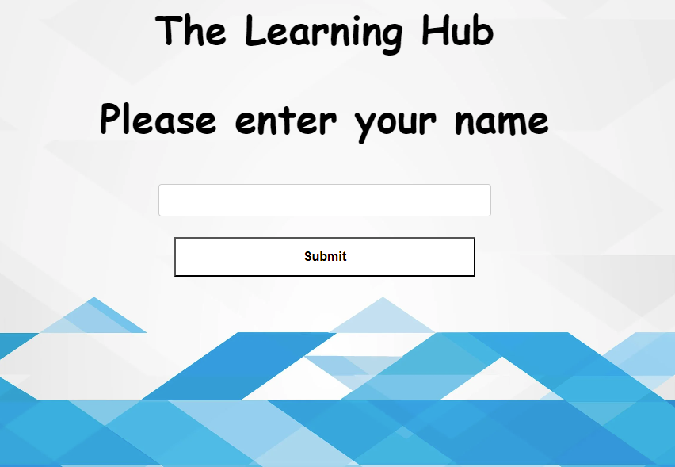

Open and friendly design. Image used to calm and welcome users. Big text identifies the platform.

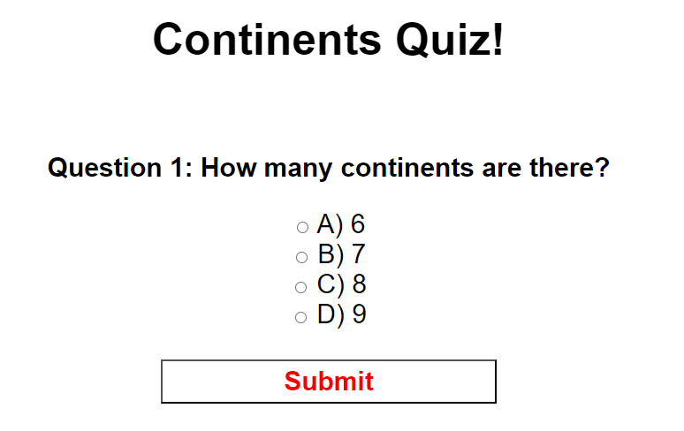

Simple and repetitive design that is easily learnable for younger children. While working functionally and practically.

Personalised message to welcome/ greet users. Easy to understand UI with simple instructions below for those who need them.

**EVALUATION- Evaluation against criteria**

To finalise this digital solution, I ineptly followed the problem-solving phases of explore, develop, generate, and evaluate/refine. The explore phase was used to fully understand the issue in full and assisted in generating relevant criteria that guided me throughout this solution.

The prescribed criteria have been met and a fully functioning and working prototype/draft platform (The Learning Hub) have been produced.

The interactive learning object, the browser game works as intended. Users have to login, where they are greeted with a personal greeting message. Students are then allowed to independently choose from a variety of learning modules (Currently only the geography module is available). From there students go through an interactive learning section that contains images and contrasting colours, as well as the design choices selected for the target audience. Students are then able to take a quick quiz on the subject they just studied to test their knowledge. The questions progressively become more difficult with the final two not having been clearly stated on the learning resource. This prompts students to use their own intuition to solve the question, similar to an A-level question on an exam that is ‘complex unfamiliar’.

To achieve all this, I planned out the User Interface (UI) and User Experience (UX) with wireframes. This allowed me to easily choose a design that aligns with the goals of this solution that meet the requirements (such as the target audience). After the planning/ design phase, I used HTML, CSS, and then further PHP to program the Platform mechanics and systems. Using decomposition, I was able to break the problem into multiple steps. The first step was to redesign the quiz program (Honestly the most taxing and time-confusing process). Reprogramming the quiz program allowed it to be more streamlined and easier to integrate into other processes and systems and allowed for easy ‘add-ons’. The next few steps were minor tasks compared to reprogramming the quiz code, these included building a login page, an interactive home page, and the learning resources/ sections.

Furthermore, my self-determined criteria required that I designed/ built the UI & UX to be friendly to the target audience (10-13-year-olds). For this, I ensured that the theme, colours (contrast), font size and styles, and placement of items were appropriate and familiar. The design was ensured to be open to everyone, as grades 5 & 6 are leading into high school and 7 are in high school, it is required to have a child-friendly feel, but have a more independent feel for those who are further along in social and mental development. The overall UI serves as a good learning tool for the slightly younger users about how modules and sections on web platforms work.

Lastly, efficient PHP code was produced to ensure that the entire platform works as intended and withholds the function stated in the criteria such as being modular and easy to add on to. By meeting this criterion, it ensures the code is easy to work on in future and easy for other developers to look at and pick up.

**EVALUATION- Impacts (Personal, Social, Economic)**

Personal impacts are those that would impact the user of the platform at a personal level. Users who spend too much time playing games, such as this can become socially withdrawn and lead to mental health issues. Just like any game, time spent using the platform should be used within judgment.

Social impacts are those that will be caused by the solution’s influence on society. This solution is designed to assist young students to firm up their knowledge before they enter high school. Students that go into high school with a good base knowledge will be able to progress faster than their peers, thus leading to more successful people in industries after education.

Economic impacts are any monetary restrictions that could inhibit users from accessing the learning platform. Although the game is currently free, the user is required to have a computer or mobile device with an internet connection which may limit low socioeconomic people from accessing this resource, further creating a gap in education (as mentioned in social impacts.)

**EVALUATION- Recommendations**

Currently, the most needed improvements would be to the overall UI, such as fixing colouring, positioning, margins and spacing. The platform also needs further ‘fool’ proofing to prevent any necessary errors, such as being able to click enter on the quiz without any option being selected.

To create a proper finished model of ‘The Learning Hub’ there would need to be the introduction of Databases to store students’ results and create classes for teachers so that student improvement can be tracked over time. This would allow teachers to better understand what subject areas specific students are struggling in.

Finally, this game is accessible to any users with an appropriate device and an internet connection. While there are social and personal impacts to be considered, simple moderation can easily balance out the negatives to create a positive learning tool to assist children in learning, and further prepare them for entering high school.

**REFERENCES**

<https://www.uwindsor.ca/openlearning/509/interactive-learning-objects>

<https://www.sciencedirect.com/science/article/pii/S1877042809003292>

<https://www.australiancurriculum.edu.au/f-10-curriculum/mathematics/?strand=Number+and+Algebra&strand=Measurement+and+Geometry&strand=Statistics+and+Probability&capability=ignore&priority=ignore&year=11757&elaborations=true>